Task 3:

Networking Basics for Cyber Security

Introduction to wire shark:-
- Wireshark is a free open source tool that analyzes network traffic in real-time for Windows, Mac, Unix, and Linux systems.
- It captures data packets passing through a network interface (such as Ethernet, LAN, or SDRs) and translates that data into valuable information for IT professionals and cybersecurity teams.
- Originally named Ethereal, the project was renamed Wireshark in May 2006 due to trademark issues.

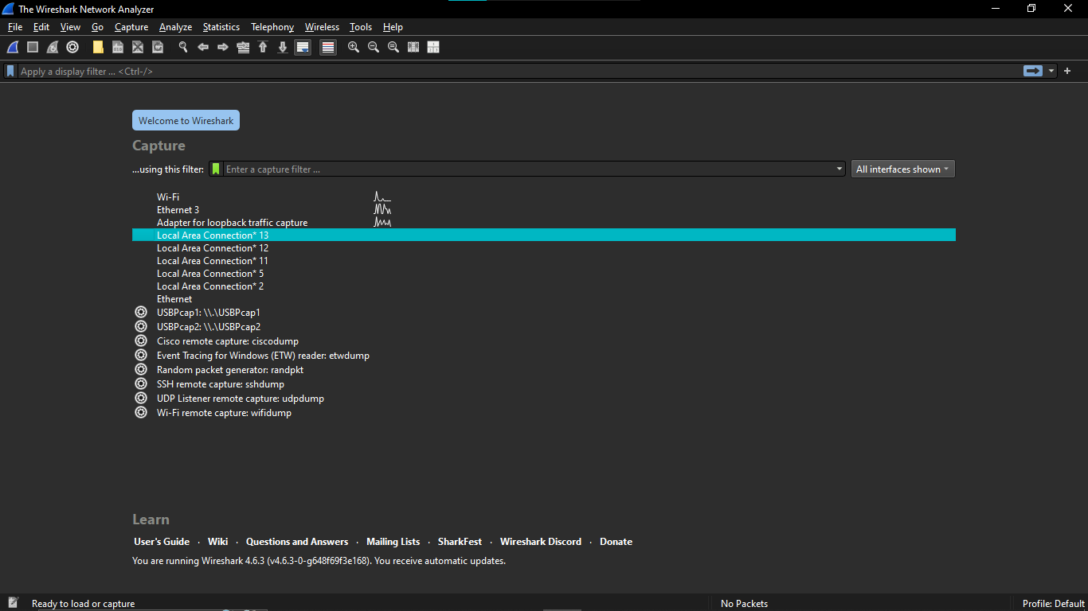
Network Traffic:

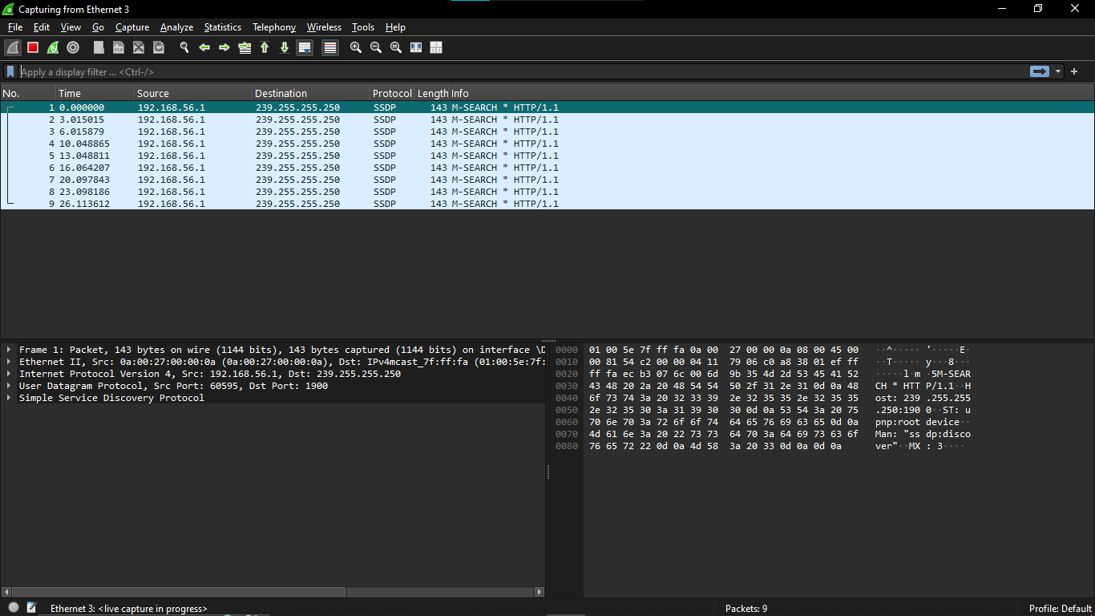
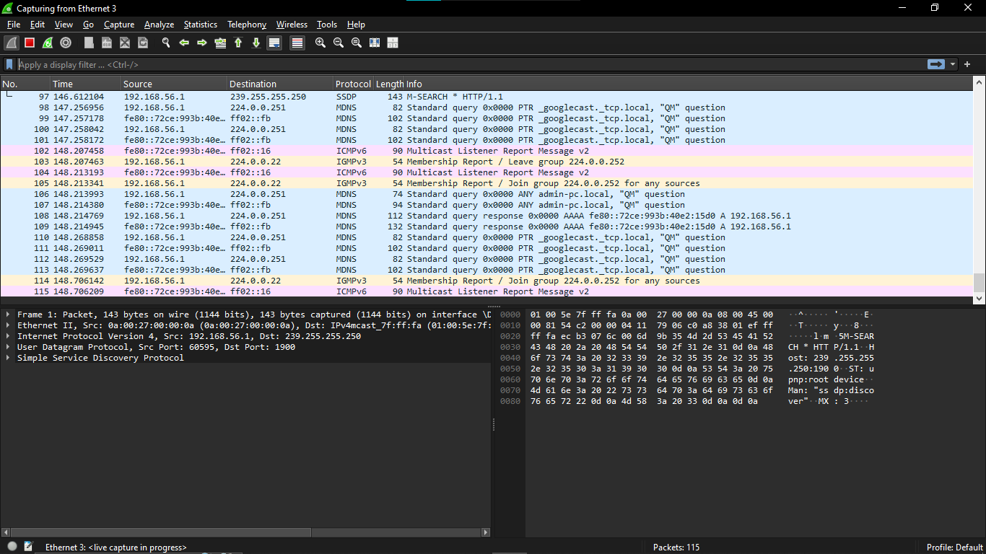

My observation:
I installed Wireshark and started capturing live traffic, and I could immediately see packets going back and forth. I used filters like TCP, HTTP, and DNS to focus on specific traffic. While looking at TCP packets, I noticed the three-way handshake with SYN, SYN-ACK, and ACK packets. HTTP traffic was readable since it wasn’t encrypted, but HTTPS traffic was encrypted so the data couldn’t be seen. I also captured DNS traffic and saw domain name requests and their IP address responses, then saved the capture file for later.

